Title of the Paper (16pt Times New Roman, Bold, Centered)

AUTHORS' NAMES (Capital, 12pt Times New Roman, centered)
Department (12pt Times New Roman, centered)
University (12pt Times New Roman, centered)
Address (12pt Times New Roman, centered)
COUNTRY (Capital, 12pt Times New Roman, centered)
Your email account@xxx.xxx.xx http://www.yourwebaddress.xx (12pt Times New Roman, centered)

Abstract: - This is a sample of the format of your full paper. You need to have A4-sized pages (21 x 29 cm) pages with top and bottom margins of 2.5 cm and left and right margins of 1.8 cm. Use single space. Use 11 pt size Times New Roman throughout the paper except for the headlines. For the words Abstract, Key-Words and References Italics.

Key-Words: - Leave one blank line after the Abstract and write your Key-Words (6 - 10 words)

JEL Classification: -

1 Introduction
As you can see for the title of the paper you must use 16pt, Centered, Bold, Times New Roman. Leave one blank line and then type AUTHORS' NAMES (in Capital, 12pt Times New Roman, centered), Department (in 12pt Times New Roman, centered), University (in 12pt Times New Roman, centered), Address (in 12pt Times New Roman, centered), COUNTRY (in Capital, 12pt Times New Roman, centered). Then you must type your e-mail address and your Web Site address (both in 12pt Times New Roman, centered).
The heading of each section should be printed in small, 14pt, left justified, bold, Times New Roman. You must use numbers 1, 2, 3, … for the sections' numbering and not Latin numbering (I, II, III, …)

2 Problem Formulation
Please, leave two blank lines between successive sections as here.
Mathematical Equations must be numbered as follows: (1), (2), …(99) and not (1.1), (1.2),…, (2.1), (2.2),… depending on your various Sections.
All Figures and Tables must be black & white with titles of 11pt, centered, bold Times New Roman.
Sample Figure:
Graph 1: EU’s imports and exports with Russia, annual data 2015-2020
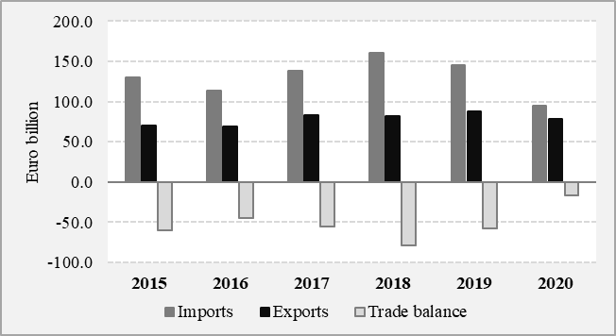
Source: Authors based on data published by the European Commission (2021).

Sample Table:
Table 1: EU main energy imports, top countries of origin (% of total), 2015-2020
Country | 2015 | 2016 | 2017 | 2018 | 2019 | 2020  (first semester)*
Oil
Russia | 31.4 | 30,0 | 32.7 | 31.0 | 28.0 | 26.4
Iraq | 4.8 | 7.9 | 8.6 | 8.5 | 8.5 | -
Saudi Arabia | 9.0 | 8.0 | 7.8 | 6.6 | 7.1 | 6.8
Norway | 9.3 | 8.4 | 8.0 | 7.8 | 7.1 | 8.0
Kazakhstan | 6.7 | 6.8 | 7.0 | 7.7 | 8.3 | 9.1
Natural gas
Russia | 41.6 | 43.7 | 41.8 | 40.4 | 44.7 | 39.3
Norway | 25.7 | 18.0 | 17.9 | 18.1 | 21.3 | 12.9
Algeria | 11.8 | 13.5 | 11.4 | 11.8 | 12.1 | 12.3
Qatar | 4.1 | 3.3 | 4.1 | 4.6 | 6.3 | -
Nigeria | 2.2 | 2.2 | 2.7 | 3.0 | 5.9 | -
Note: * Last available data.
Source: Authors’ computations based on (Eurostat, 2021).

2.1 Subsection
When including a subsection you must use, for its heading, small letters, 12pt, left justified, bold, Times New Roman as here.

2.1.1 Sub-subsection
When including a sub-subsection you must use, for its heading, small letters, 11pt, left justified, bold, Times New Roman as here.

3 Problem Solution
Figures and Tables should be numbered as follows: Fig.1, Fig.2, etc. Table 1, Table 2, ….above the Figure and Table, aligned centered etc.
When citing in the text please type the corresponding references in round brackets as shown at the end of this sentence (Author, Year).

4 Conclusion
Please, follow our instructions faithfully otherwise you have to resubmit your full paper. If your paper deviates significantly from these specifications, we may not be able to include your paper in our review.
References:
- Author (Year). Title of the Paper. International Journal of Science and Technology, Vol.X, No.X, pp. XXX-XXX.
- Author (Year). Title of the Book. Publishing House.

